**These are the notes referred to on the following official copy**

Title Number NGL498342

The electronic official copy of the document follows this message. This copy may not be the same size as the original.

Please note that this is the only official copy we will issue. We will not issue a paper official copy.

# DATED 1984

LONDON AND AUCKLAND ESTATES

and

# FLATS & ESTATES DEVELOPMENTS LIMITED

to

# PETER ROY MAINPRIZE

LEASE OF

Flat 8 Langham Court, Acol Cresent, South Ruislip, Middlesex

# TERM

from

125 Years

29th September 1983

INLAND G[J REVENUE

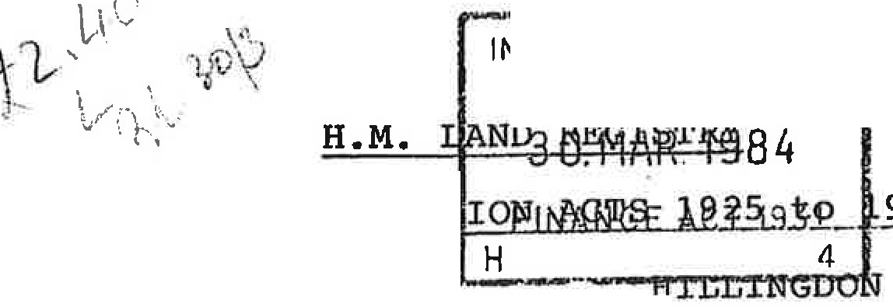

PRODUCED

## LAND REGISTRA

LONDON BOROUGH TITLE NUMBER

## MX 352603

971

## PROPERTY

FIRST FLOOR FLA'!' 8 LANG COURT, ACOL CRESCENT, SOUTH RUISLIP, MIDDLESEX

F



or

TH IS L -.SE is made the,• d**o**a**f**y**a**

One thousand nine hundred and eighty-

E T W E E N.

LONDON & AUCKLAND ESTATES :Q-.!. whose registered office at High Holborn House 52/54 High Holborn London WClV 6

{"the Lessor" which expression shall include the person persons for the time being entitled to the reversio immediately expectant on the determination of the term here created) of the first part PETER ROY MAINPRIZE of 8 Langh Court Acol Crescent South Ruislip Middlesex ("the Lessee" which expression shall where the context so admits include his successors in title) of the second part and FLATS &

ESTATES DEVELO ME2._ -LI ,!_TED whose registered office is at High Holborn House aforesaid (hereinafter called "the Company") of the third part BY WAY OF EXTENSION of the term of years created by the lease (hereinafter called "the Lease") short particulars whereof are set out in the Schedule hereto

WITNESSES that in consideration of the sum of £535. 00 now paid by the Lessee to the Lessor the receipt of which sum the Lessor hereby acknowledges the Lessor HEREBY DEMISES unto the

Lessee A,LL 'AND SINGULAR the premises comprised in and demised

·, .

by the Lea:se;_1,'t0GE!J.'HER WITH but except and reserved the rights

. . • . ,. ..•. ·.'. I

of way and ·9t er matters mentioned in the Lease TO HOLD the same . unto· t}:le • L Ssee for a term of 125 years from 29th

Sept mber 1983**:**'.**:YIELDING AND PAYING** therefor the same rent as

/·



is reserved by the Lease AND IT IS HEREBY AGREED AND DECLARED that the Covenants and conditions contained *in* the Lease shall apply (mutatis mutandis) to this demise as if they were herein set out in extenso

**IT IS** HEREBY CERTIFIED that the transaction hereby effected does not form part of a larger transaction or of a series of transactions in respect -0f which the amount or value or the aggregate amount or value of the consideration exceeds

£25,000.00

IN WITNESS whereof the Lessor and the Company have caused their Common Seals to be hereunto affixed and the Lessee has set his hand and seal the day and year first before written

THE SCHEDULE above referred to

**DATE OF' LEASE**

**PARTIES TERM**

# RENT

TITLE NO

22nd November 1957

Davis Contractors Limited (1) Constance Mary Brunskill

Ruth Marjorie Pentney (2) Flats and Estates

99 years from 25th March 1957

£10 per annum

# MX 352603

Developments Limited (3)

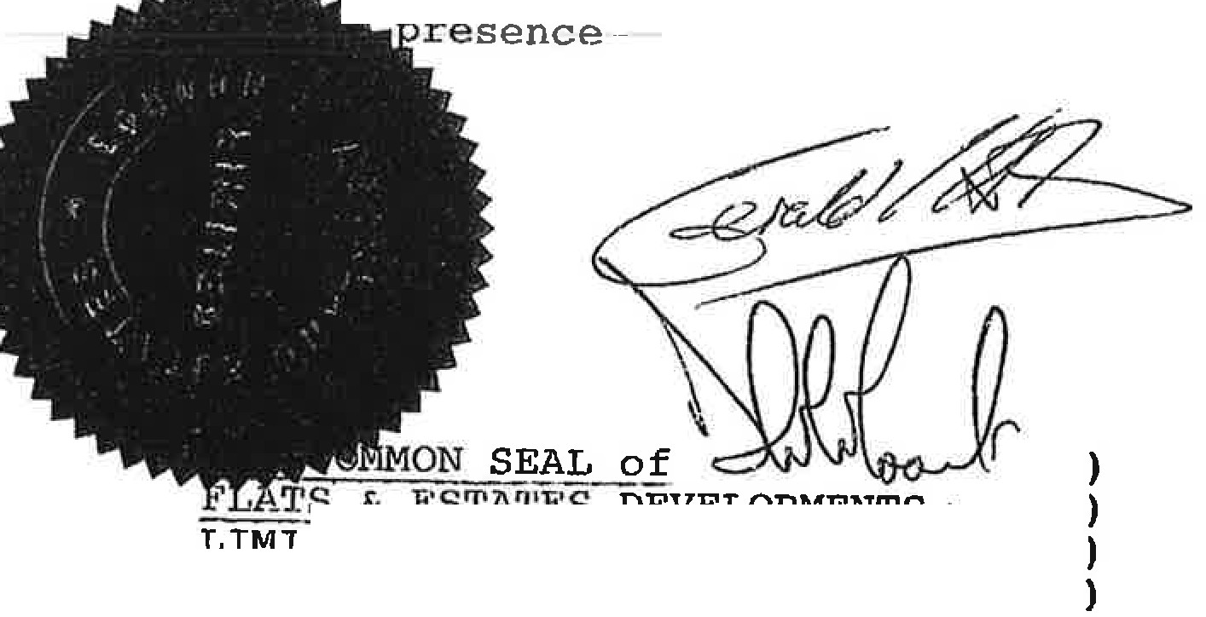

LONDON & AUCKLAND ESTATES LIMITED)

hereunto affixed • )

)

_TS &

DEVELOPMENTS •

LIMITED was hereunto affixed in the presence of

THE COMMON SEAL of )

--·--·... -· -·

· {J - .

., .,.



*:* ;

  